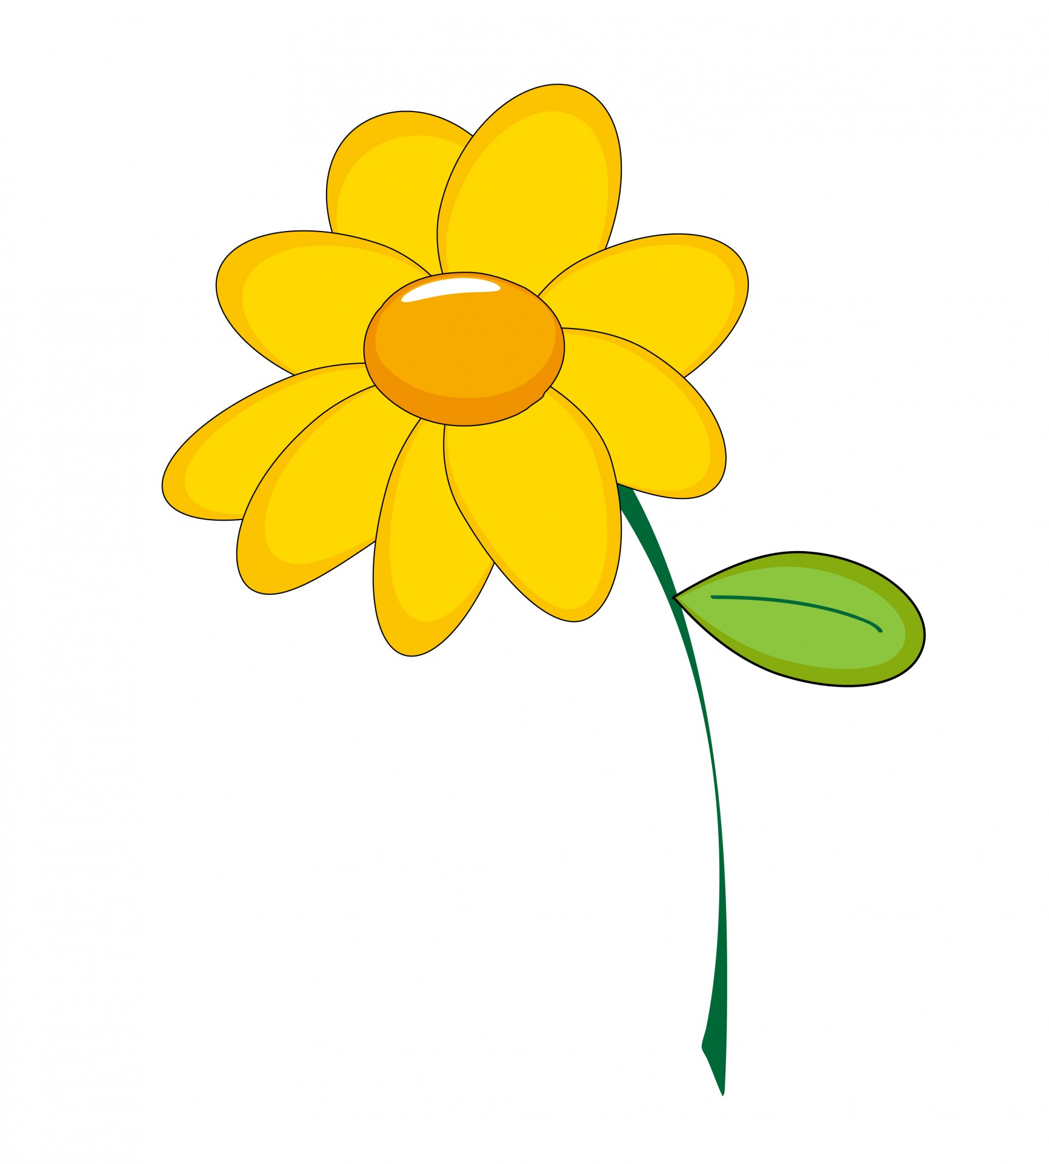
Look At How I’ve Grown
I have learned many new things this year.
I Am…
_________________________________________________________________________________________________________________________________________________________
I Can…
I Know…
I Know…

